EXPERIMENT – 3(A)
PANDAS LIBRARY – DATA PREPROCESSING
Aim:
To understand the importance of data preprocessing in data science
Procedure:
- Upload the given dataset(csv file) and read it
- Import necessities such as numpy ,pandas
- Now , process the data , find missing values and replace it with mean(),mode(),median()

Program:
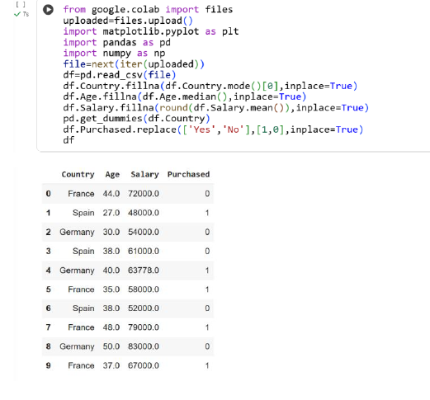

Result:
Thus the python program to find missed values and replacing it was executed and verified
EXPERIMENT – 3(B)
PANDAS LIBRARY – HANDLING MISSING VALUES
Aim:
To handle and analyze missing and inappropriate data in dataset
Procedure:
- Upload the csv file and read it
- Import necessities such as pandas , numpy
- Now check for missing and inappropriate data to replace with appropriate data
Program:
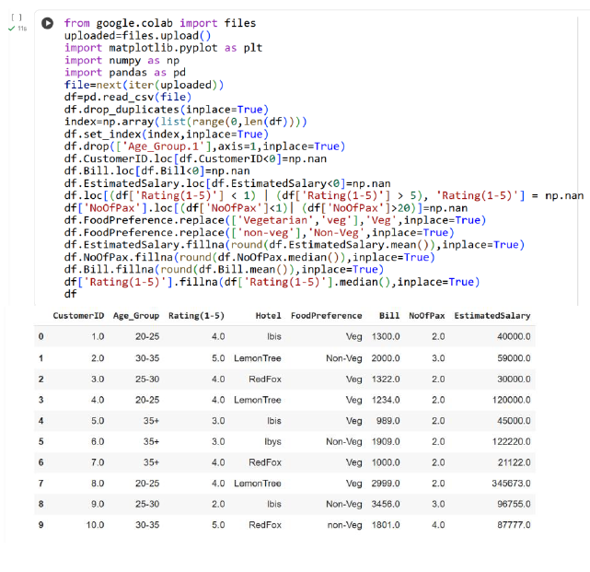

Result:
Thus we find missing and inappropriate data and replaced with appropriate ones
EXPERIMENT-3(C)
PANDAS LIBRARY – CREATE CSV FILE
Aim:
To create a dataset and make it as csv file and handle inappropriate values
Procedure:
- Create a dataset
- Import pandas and numpy and with its help, create dataframe and change it to csv file
- Read the dataset and handle inappropriate and missing values

Program:
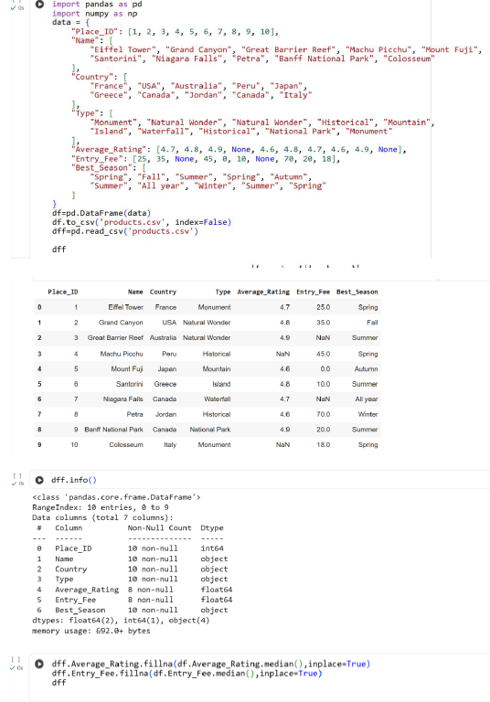
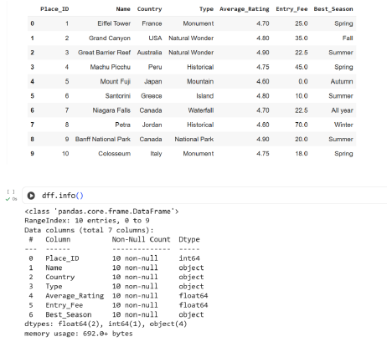
Result:
Thus the python program to create own dataset and change it to csv file is executed and verified

